### 

### Semester One Examination, 2020

### Question/Answer booklet

# MATHEMATICS SPECIALIST

**UNIT 1**

## Section One:

## Calculator-free

|  |  |
| --- | --- |
| **Your Name:** |  |
| **Your Teacher’s Name:** |  |

## Time allowed for this section

Reading time before commencing work: five minutes

Working time: fifty minutes

## Materials required/recommended for this section

***To be provided by the supervisor***

This Question/Answer booklet

Formula sheet

***To be provided by the candidate***

Standard items: pens (blue/black preferred), pencils (including coloured), sharpener, correction fluid/tape, eraser, ruler, highlighters

Special items: nil

## Important note to candidates

No other items may be taken into the examination room. It is **your** responsibility to ensure that you do not have any unauthorised material. If you have any unauthorised material with you, hand it to the supervisor **before** reading any further.

|  |  |  |  |  |  |
| --- | --- | --- | --- | --- | --- |
| Question | Marks | Max | Question | Mark | Max |
| 1 |  | 4 | 5 |  | 8 |
| 2 |  | 6 | 6 |  | 12 |
| 3 |  | 5 | 7 |  | 6 |
| 4 |  | 5 | 8 |  | 4 |

**Structure of this paper**

|  |  |  |  |  |  |
| --- | --- | --- | --- | --- | --- |
| Section | Number of questions available | Number of questions to be answered | Working time (minutes) | Marks available | Percentage of examination |
| Section One:  Calculator-free | 7 | 7 | 50 | 46 | 35 |
| Section Two:  Calculator-assumed | 12 | 12 | 100 | 100 | 65 |
|  |  |  |  | **Total** | 100 |

**Instructions to candidates**

1. The rules for the conduct of the Western Australian Certificate of Education ATAR course examinations are detailed in the *Year 11 Information Handbook 2019*. Sitting this examination implies that you agree to abide by these rules.
2. Write your answers in this Question/Answer booklet.
3. You must be careful to confine your answers to the specific questions asked and to follow any instructions that are specific to a particular question.
4. Additional pages for the use of planning your answer to a question or continuing your answer to a question have been provided at the end of this Question/Answer booklet. If you use the space to continue an answer, indicate in the original answer space where the answer is continued, i.e. give the page number.
5. **Show all your working clearly.**Your working should be in sufficient detail to allow your answers to be checked readily and for marks to be awarded for reasoning. Incorrect answers given without supporting reasoning cannot be allocated any marks. For any question or part question worth more than two marks, valid working or justification is required to receive full marks. If you repeat any question, ensure that you cancel the answer you do not wish to have marked.
6. It is recommended that you **do not use pencil**, except in diagrams.
7. The Formula sheet is **not** to be handed in with your Question/Answer booklet.

**Section One: Calculator-free (46 Marks)**

This section has **seven** questions. Answer **all** questions. Write your answers in the spaces provided.

Spare pages are included at the end of this booklet. They can be used for planning your responses and/or as additional space if required to continue an answer.

● Planning: If you use the spare pages for planning, indicate this clearly at the top of the page.

● Continuing an answer: If you need to use the space to continue an answer, indicate in the original answer space where the answer is continued, i.e. give the page number. Fill in the number of the question that you are continuing to answer at the top of the page.

Working time: 50 minutes.

**Question 1** {1.1.1, 1.1.3} **(4 marks)**

1. Solve (2 marks)



1. Evaluate (2 marks)



**Question 2** {1.3.1, 1.3.2, 2.3.1}  **(6 marks)**

Consider the following statement:

*If the diagonals of a quadrilateral are equal in length, then the quadrilateral is a square*

1. Write the converse of the statement and state whether it is true or false. (2 marks)

If a given quadrilateral is a square, then its diagonals are equal in length.

True.

1. Write the inverse of the statement and state whether it is true or false. (2 marks)

If the diagonals of a quadrilateral are not equal in length, then the quadrilateral is not a square.

True.

1. Write the contrapositive of the statement and state whether it is true or false. (2 marks)

If a given quadrilateral is not a square, then its diagonals are not equal in length.

False.

**Question 3** {2.3.1}  **(5 marks)**

1. Prove the following statement: (4 marks)

If is 3 more than a multiple of 6, then is also 3 more than a multiple of 6.



1. Is there an integer such that is equal to 3 more than a multiple of 6? Explain briefly. (1 mark)



**Question 4** {2.3.3} **(5 marks)**

Prove by contradiction that is irrational.

*Assume that is rational. ✓*

*Then where and are coprime integers. ✓*

*Rearranging,*

*is even.*

*is even.* ✓

*Hence, for some integer .*

*Substituting,*

*is even.*

*is even, since 5 is odd.*

*is even.* ✓

*Since and are both even, they cannot be coprime.*

*Therefore, cannot be rational.* ✓

**Question 5** {1.2.1-1.2.4, 1.2.6-1.2.9} **(8 marks)**

Points P and Q have position vectors of and respectively, relative to the origin O.

1. Determine the unit vector of the displacement of Q relative to P in terms of and (3 marks)



1. Give the direction of the vector in part (a) as a bearing if the unit vector is pointing due North. (2 marks)

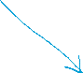

1. Vector has magnitude and is parallel to the vector in part (a) and in the opposite direction. Determine in terms of and **.** (3 marks)



**Question 6** {1.2.10, 1.2.11, 1.2.12} **(12 marks)**

1. Find the value of given that the angle between vector and is .

(5 marks)

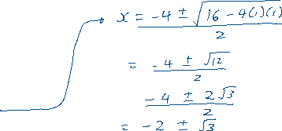

1. Find the value of the constant given that vector is perpendicular to .

(2 marks)



1. The vectors and are such that , and . Evaluate
   1. (2 marks)



* 1. (3 marks)



**Question 7** {1.3.6, 1.3.8, 1.3.10, 1.3.11} **(6 marks)**

Consider the diagram below which consists of a circle with the centre , its two tangents and , and a chord which subtends the angle on the circumference of the circle.

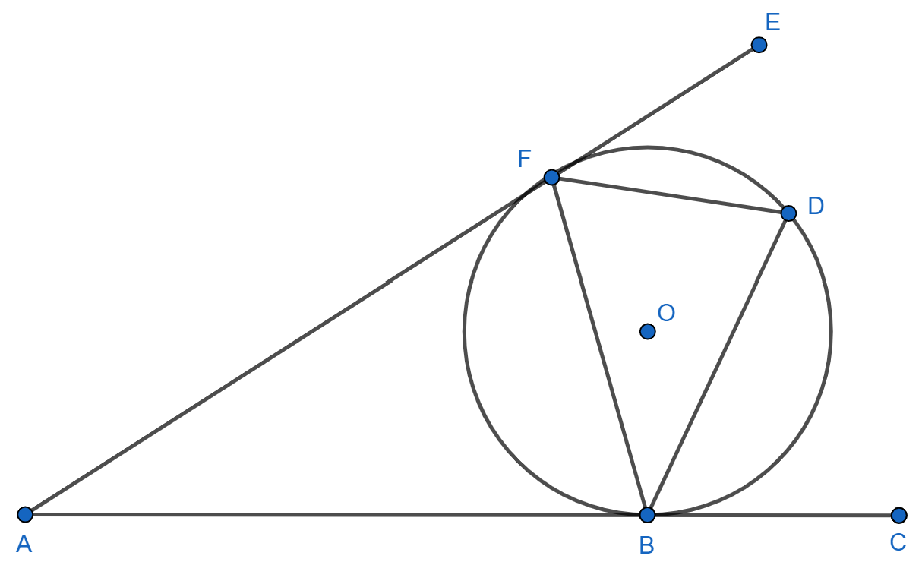



1. Prove that . (Note that it is not sufficient to simply quote a theorem that states they are equal.) (2 marks)



1. Prove that (Note that it is not sufficient to simply quote a theorem stating they are equal.) (4 marks)

Additional working space



Question number: ________

Additional working space

Question number: ________

Additional working space

Question number: ________